Learning disability annual health check invite letter
Ponteland Medical Group Telephone 01661 825513

Named Receptionist: Anne-Louise Thompson
GP: Dr Hannah Brown

NHS number……………………… Date of birth………………Date………………
Dear

Coronavirus has changed the way your GP Surgery works but we still want to make sure you are keeping well and that you know you can contact your GP Surgery if you have any health worries. | 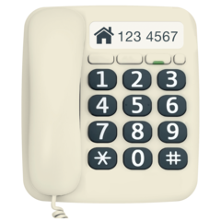
We think your annual health check is really important and we want to see you for this check-up.
You will find with this letter a learning disability annual health check questionnaire that we would like you to complete | 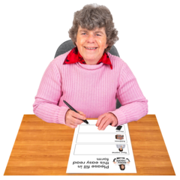
You can ask a family member, carer or friend to help you complete it. If you don’t have anybody to help you and need some help, then please let us know
When you have completed your questionnaire, we would like you to bring the questionnaire to the appointment that we have booked for you.  At this appointment we will talk about what you have put in your questionnaire. | 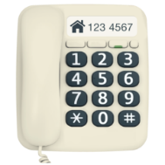
Once all of the questions have been asked the doctor will think about what to do next. You might need to come to the GP practice for some tests or we might be able to wait until your next health appointment. | 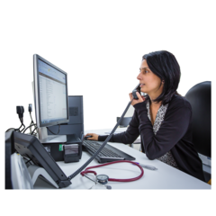
If you are asked to come to the GP practice, please don’t worry we will make sure it is safe and will only ask you to come if it is necessary. | 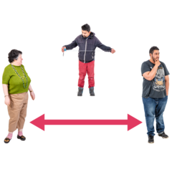
The practice might look a bit different to what you might be used to and our staff will be wearing personal, protective equipment that will help keep them and you safe.

It is really important that you complete this questionnaire and make an appointment to have your annual health check | 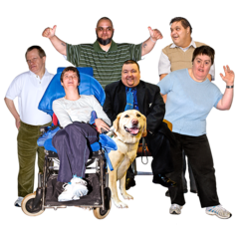
An annual health check helps to keep you fit and well

If you have any questions, please contact us using the contact details at the top of this letter

Yours sincerely  Dr Hannah Brown | 